**Ethereal – MYTH**

**MYTH description**

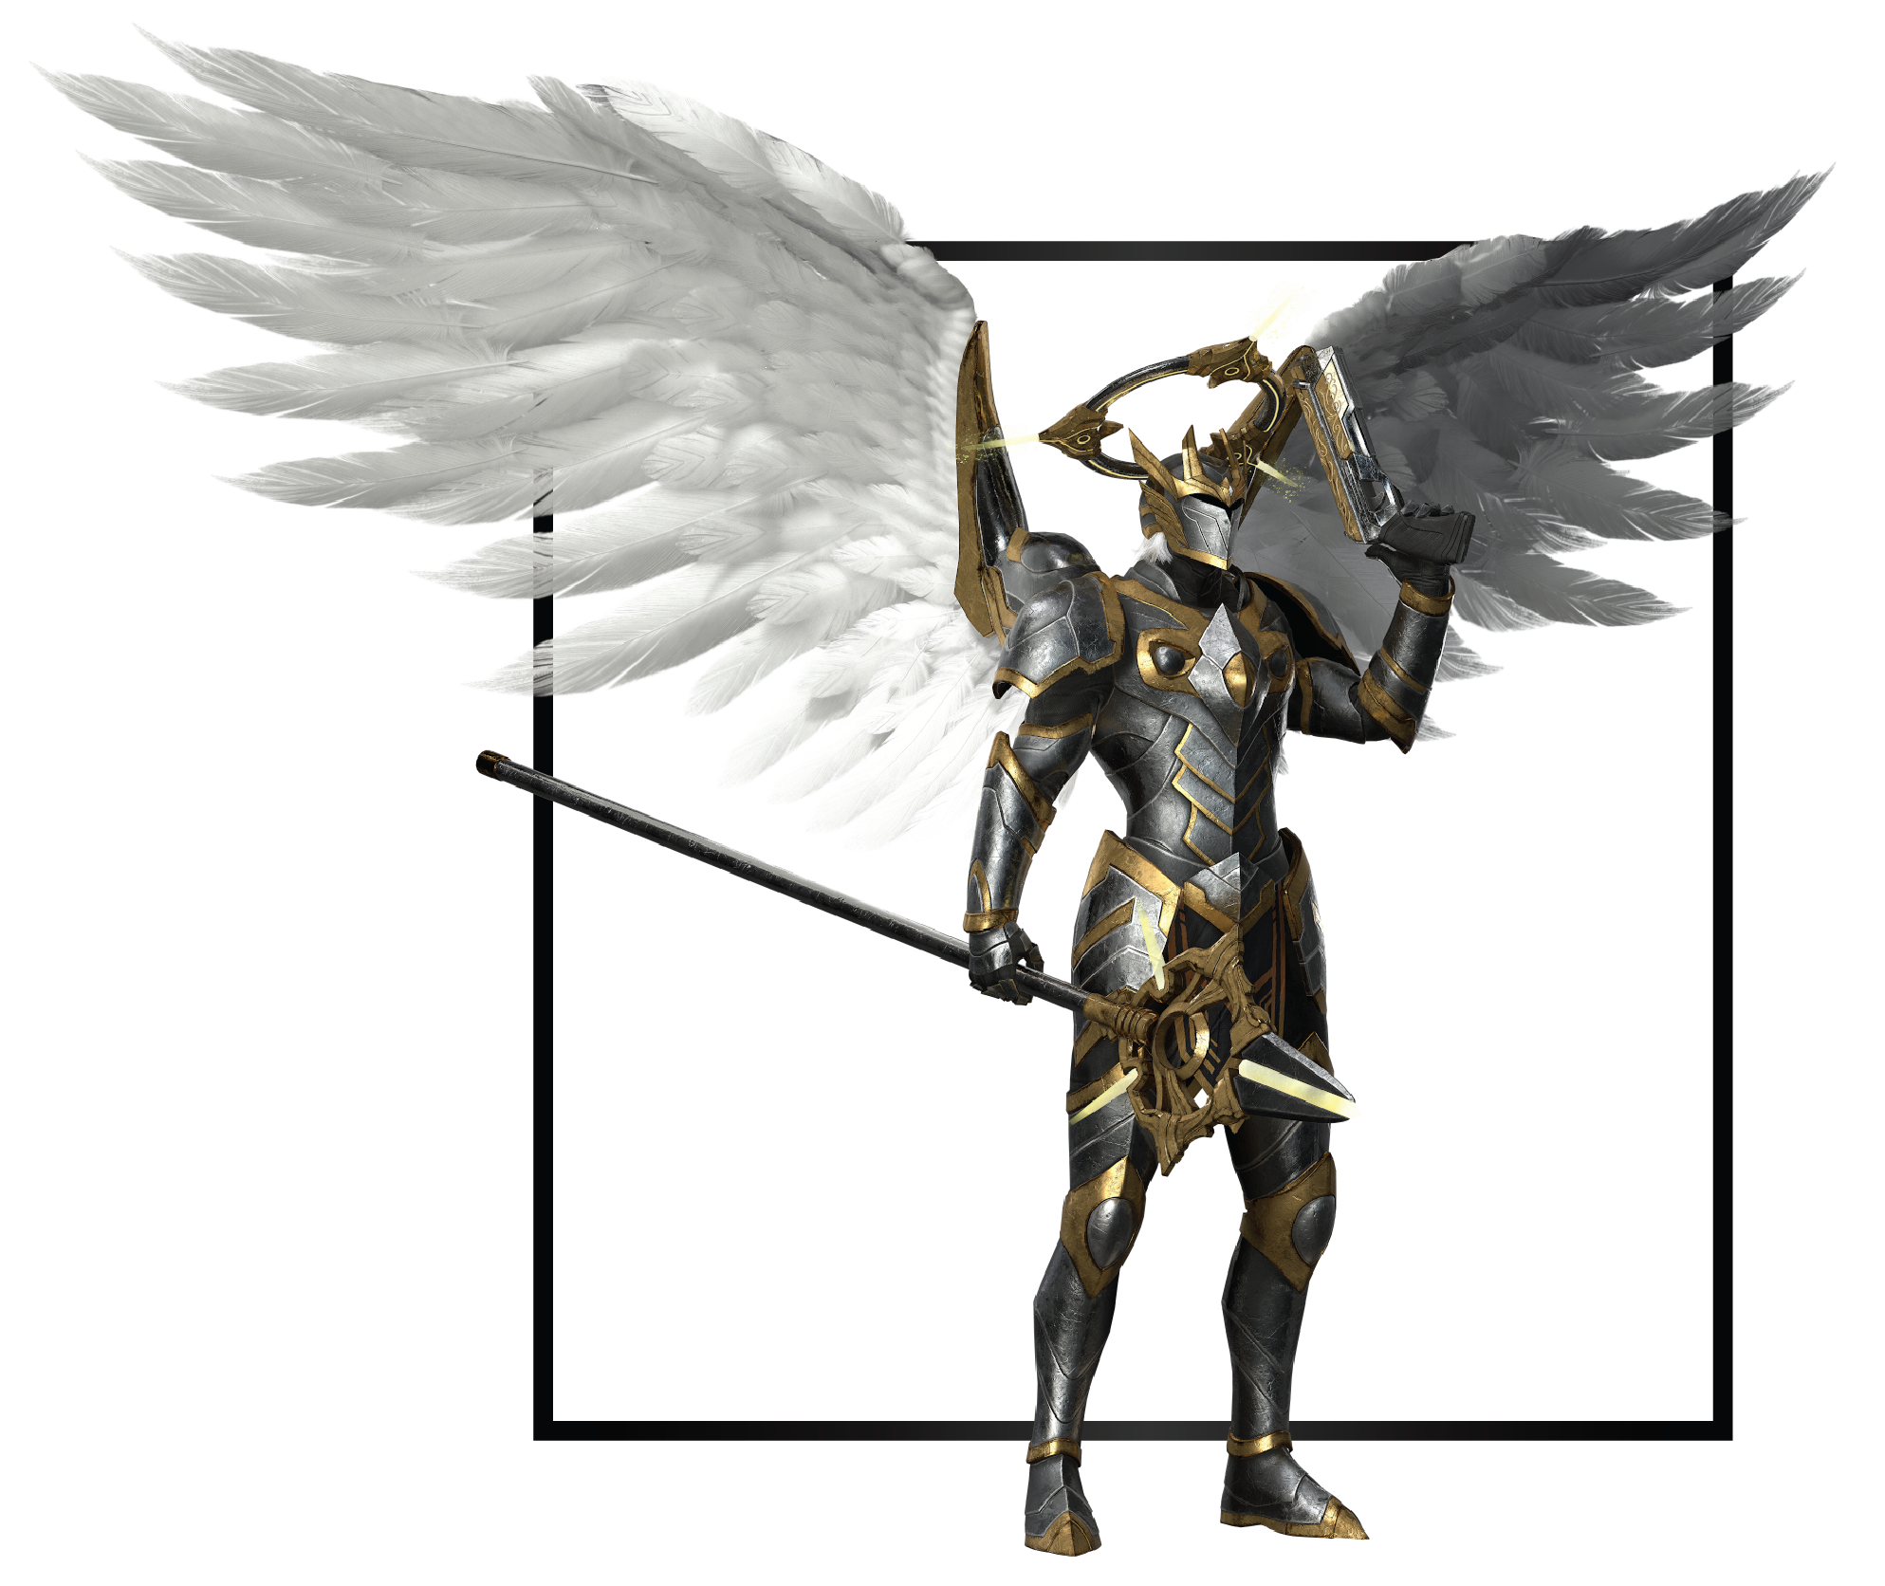

|  |  |
| --- | --- |
| **Name** | Zero |
| **Title** | Light’s Herald |
| **Realm** | Citadel |
| **Region** | Inner Citadel |
| **Class** | Sky Slayer |
| **Type** | Melee / Ranged Physical |
| **Release Date** | Coming Soon |

An Archangel named Zero was the leader and most powerful Guardian, endowed with all admirable qualities possible in beings that walk the mortal planes. Wisdom had Zero in abundance, and shrewd was he in matters of strategy. Strength came naturally to him, for his power was that of the Light. Compassion and mercy remained within him, yet ruthless was he to those that embraced Darkness and Azrail’s teachings. His capacity for leadership and the strength to see Cael’s will carried out made Zero the perfect commander of the forces of Light. It took all of this and more to stop the Anima Schism and drive Arawn’s invading forces back to Kraxus. The aftermath would show to be more challenging as Zero faced the consequences of his actions, causing other Guardians to rise to dispute his position.